How to Register
- Go to https://www.mandurah.wa.gov.au
- Click on Online Services
- Click apply for it
- Click on Don’t have an account?

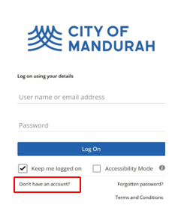
- Click “Registering Email”

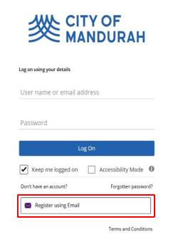

QUICK REFERENCE GUIDE

- Complete the following questions

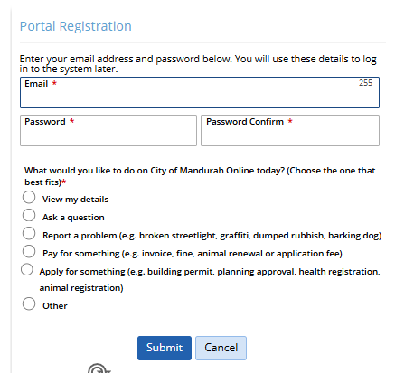

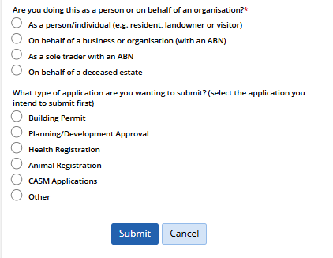

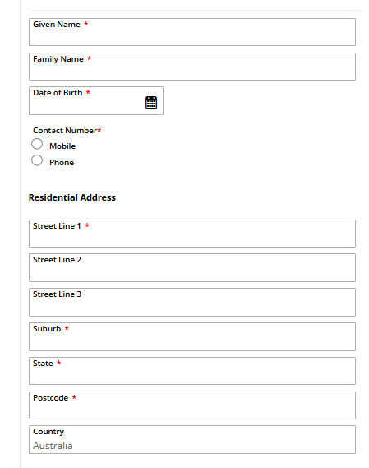
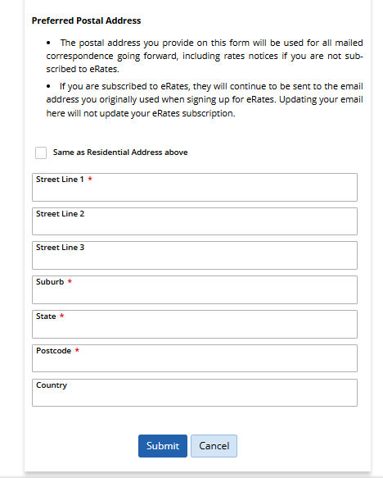

Once completed and and submitted you will receive and message
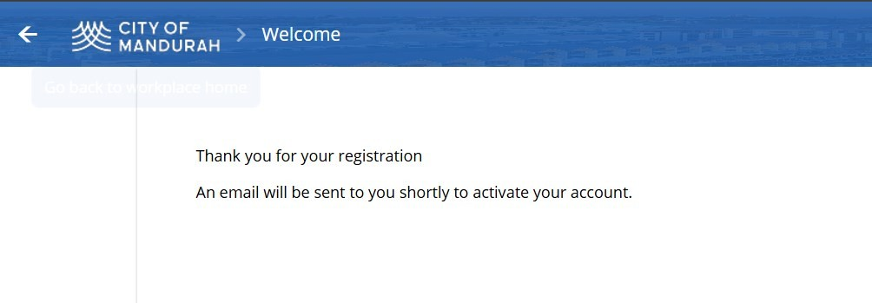

7/ Check your email for a verification email. Please also check junk/spam folder.
Click “HERE “to verify your email (as per below)
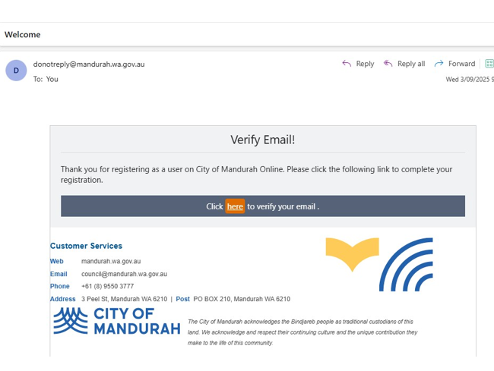

The login page will open, with confirmation that your email has been verified. Please login using your details
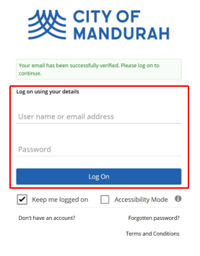
8/ Two Factor Authentication:
You will be prompted to setup Two Factor Authentication- this is mandatory. There are three methods available to use:
- Authenticator App
- Email Link
- Email Code (Best option)
Click okay
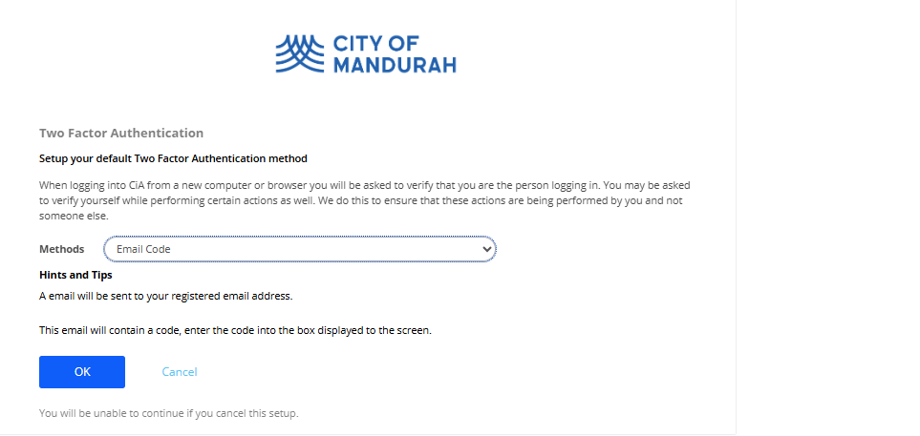
Check your email for verification code as per below
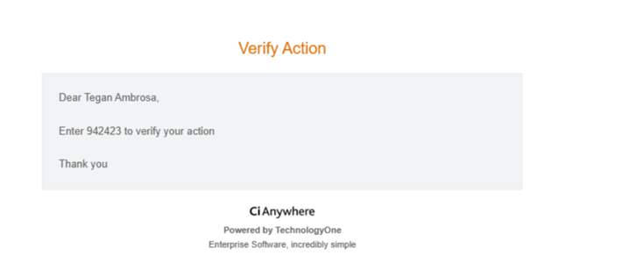
Type in the One-Time- Code into the portal and click OK.
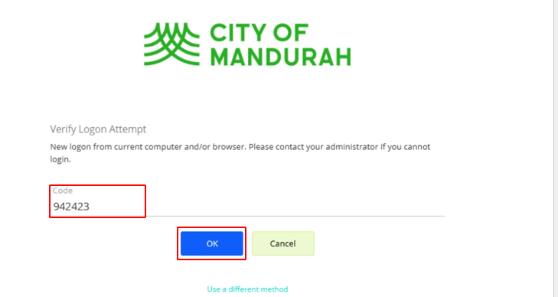

9/ The login page will open, with confirmation that your email has been verified. Please login using your details.

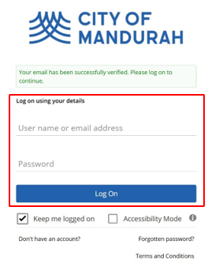

10/ Read and Accept the Terms and Conditions

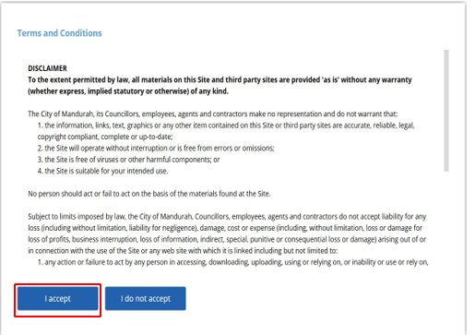
Now you are ready to access the portal

